Example Lesson Plan of CCCC 2016:

What analyzingverbs that take complement clauses in academic writing can teach us about disciplinarity:

Objectives: 1) to construct a search in COCA, 2) to analyze searches in COCA, 3) to observe and comment on variations across disciplines, 4) to think about the rhetorical situations of disciplines

* 1. Set up: Introduce the problem. Students often have trouble with the verbs that come before complement clauses, e.g.
     1. *[Author] Verbs* *that ______*,

when attributing an action to an author,or

* + 1. *I Verb that ______*,

when personally asserting or commenting. When commenting on this difficulty students have, many instructors of writing claim that their students’ knowledge of verbs is limited, but it’s only a small subset of all verbs that they are referring to. Using corpus tools, how can we figure out what kinds of verbs are used in these constructions, as well as the kinds of rhetorical moves these verbs signal in academic writing composed by experienced writers?

* 1. COCA: The Corpus of Contemporary American English is a free online corpus available to you and students, and it allows you to adequately answer the question above. For the sake of time, we will be looking into (ii), but (i) provokes interesting questions worth considering, too—for example, how and what for students and expert writers use sources.  
       
     Looking at the COCA main page, we can see that there are a number of things going on. We want to direct our attention to the tools pane on the left, and particularly the part in the top left that reads **search string**. Here, we need to come up with a way to search *I Verb that*. If we try to just type in “verb,” in place of a verb, we run into a problem:

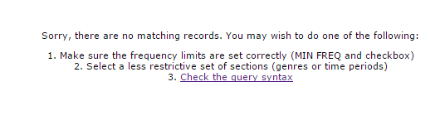

We need to type our search in a way that the computer can read, and while it can read “I” and “that,” and “verb” individually, it can’t replace the *word* “verb” for the empty slot where verbs would be inserted.

To let COCA know that we want it to return sentences from its database in the form *I Verb that*, we have to replace the word *Verb* with a particular part of speech. In English, each lexical verb has six different forms: three finite forms and three non-finite forms. The kind of verb that we are looking for is a finite plain present tensed lexical verb, often called the “base form” of a verb.   
  
To figure out how to write that verb form into COCA, we can click on the question mark box next to the POS LIST row  
  
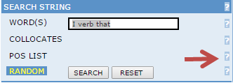

Doing so will bring up a help page in the info and help pane. There we see a few things. First, that when we want to have COCA return particular parts of speech, we have to put that part of speech in square brackets [ ]. Second, we need to figure out what the part of speech tag code is that would go into those square brackets. We find that in the list that COCA links to, the CLAWS C7 tagset. If we scroll down of use a find function, we can quickly find that the tag that we are looking for is [vv0]:

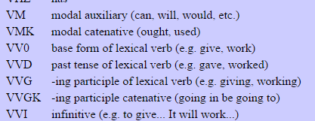

So now we have our search string: I [vv0] that  
  
But before we click Search, we want to look down to the other tools in the tools pane. Notice that one of the tools, the one that says Sections, has a section for **Academic**, which is comprised of 120 million words from expert, published academic writers. Since we only want to see the verbs that academic writers use, we want to click on Academic before we hit search.

* 1. Obtaining Lists: Now that we have hit search, we are given a list of strings in the form *I Verb that*, exactly like we wanted. Notice that these verbs are organized by the frequency that they occur in the COCA Academic subcorpus. Our list should look like this:

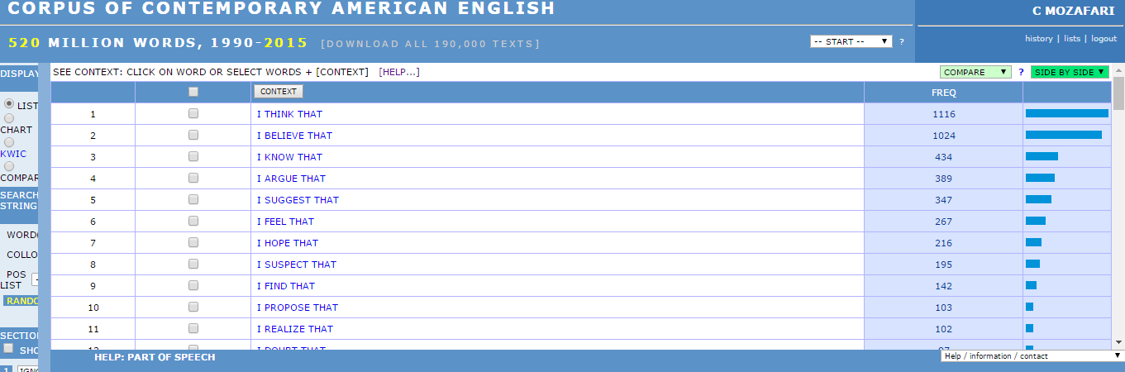

The first most frequent verb that appears in this first person construction is the verb “think,” which has a frequency of 1116 hits. This is followed by the word “believe,” which is has a frequency of 1024, and “know,” which has a frequency of 434. It’s worth noting that *think*, *believe*, and *know* are all verbs that have to do with mental states, and in this instance, it’s the mental state of the *I* of the string. We can further investigate these sentences if we click on any of these strings. When we click on *I THINK THAT*, for example, we get a very large list, where I can see the year of the publication, some background information about the publication, and the immediate context of the string we searched for:

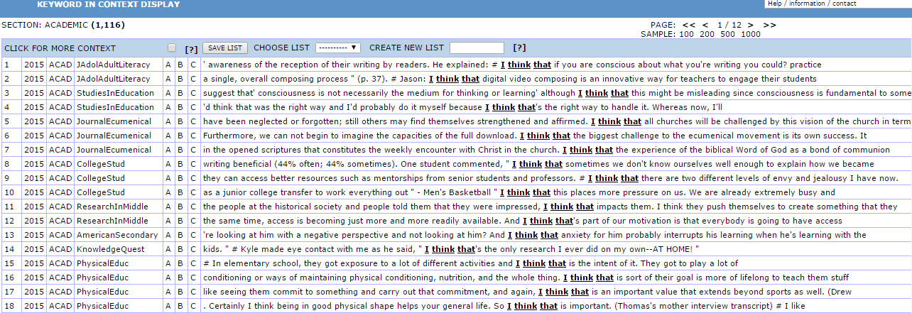

Going back to the upper pane with the list of strings and frequencies, notice that huge drop in frequency between *thinking* and *believing* on the one hand and *knowing* on the other. This may be an interesting area to explore. Why might academics in general *think* and *believe* more than they *know*?  
  
In any case, let’s write down the first 10 verbs here and continue on with our exploration. Our list is as follows:

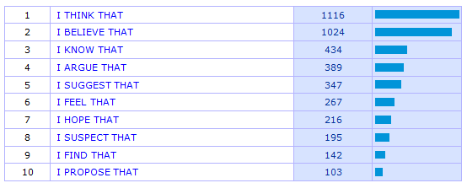

* 1. Disciplinary writing: But what if we want to know, for example, what sorts of complement clause licensing verbs writers in the humanities use? What if we want to see if there is a difference between legal writing and science writing? Thankfully, COCA allows us to get more specific with our search.  
     We are going to repeat our search term ( ***I [vv0] that*** ) but this time, instead of just clicking on Academic under the Sections page, we are going to scroll down and see the subcorpora in the Academic corpora. We can see that COCA organizes its data in the following categories:
     1. ACAD: Education
     2. ACAD: History
     3. ACAD: Geog/SocSci
     4. ACAD: Law/PolSci
     5. ACAD: Humanities
     6. ACAD: Phil/Rel
     7. ACAD: Sci/Tech
     8. ACAD: Medicine
     9. ACAD: Misc

In small groups, your task is to do what we just did for the general search but within the disciplinary subcorpora assigned. Record the first ten verbs, as we did, but, with your partner, inquire as to why you find these verbs in this particular discipline. Do you feel as if there is some meaningful reason why certain verbs in the *I Verb that* construction within a particular discipline are more frequent? We will come back together, report our findings, and think about how this sort of work could help us and our students to think about the kinds of rhetorical and linguistic actions motivated by discipline-specific discourse.

* 1. Let’s finish with a quick observation. We started with a common pedagogical problem that comes about from close proximity to our students’ work: our students don’t often have the best vocabulary, particularly in contexts where they need to find a verb that licenses a complement clause in an effective way. We looked at one particular configuration where this problem shows up; that is, when considering a sentence of the form *I Verb that ______*.

We now see that while we can see general trends in academic writing, different disciplines solve this verb problem in different ways. For example, *I Verb that* strings are not very frequent in writing within the field of Medicine, whereas they are surprisingly frequent in Law and Political Science. While some verbs overlap between categories, we can imagine that the presence or absence of a verb, as well as the relative frequency of its tendency to license a complement clause after a first person pronoun, can telling us something about the kinds of moves academics make within particular disciplines.

And this is a fruitful conversation to have with students, as well as with fellow instructors of English composition. What we are observing is in a sense the rhetorical situations of particular disciplines. Sometimes, the rhetor’s objective in a discipline-specific rhetorical situation changes. We can now hypothesize as to why these objectives change and what these changes look like, given the data we are able to analyze using corpus linguistic methods. While many of us teach Academic Writing or First Year Writing courses, not courses specific to Writing in the Disciplines, our work with corpus methods and careful close reading is able to allow us to observe how well we are preparing students for writing in the academy.

Top 10 for Education

|  |  |  |  |
| --- | --- | --- | --- |
| 1 | [I THINK THAT](http://corpus.byu.edu/coca/x3.asp?xx=1&w11=i&w12=think.%5bvv0*%5d&w13=that&r=145) | 121 | http://corpus.byu.edu/coca/k.jpg |
| 2 | [I BELIEVE THAT](http://corpus.byu.edu/coca/x3.asp?xx=2&w11=i&w12=believe.%5bvv0*%5d&w13=that&r=145) | 102 | http://corpus.byu.edu/coca/k.jpg |
| 3 | [I FEEL THAT](http://corpus.byu.edu/coca/x3.asp?xx=3&w11=i&w12=feel.%5bvv0*%5d&w13=that&r=145) | 57 | http://corpus.byu.edu/coca/k.jpg |
| 4 | [I KNOW THAT](http://corpus.byu.edu/coca/x3.asp?xx=4&w11=i&w12=know.%5bvv0*%5d&w13=that&r=145) | 49 | http://corpus.byu.edu/coca/k.jpg |
| 5 | [I HOPE THAT](http://corpus.byu.edu/coca/x3.asp?xx=5&w11=i&w12=hope.%5bvv0*%5d&w13=that&r=145) | 23 | http://corpus.byu.edu/coca/k.jpg |
| 6 | [I ARGUE THAT](http://corpus.byu.edu/coca/x3.asp?xx=6&w11=i&w12=argue.%5bvv0*%5d&w13=that&r=145) | 18 | http://corpus.byu.edu/coca/k.jpg |
| 7 | [I SUGGEST THAT](http://corpus.byu.edu/coca/x3.asp?xx=7&w11=i&w12=suggest.%5bvv0*%5d&w13=that&r=145) | 14 | http://corpus.byu.edu/coca/k.jpg |
| 8 | [I FIND THAT](http://corpus.byu.edu/coca/x3.asp?xx=8&w11=i&w12=find.%5bvv0*%5d&w13=that&r=145) | 13 | http://corpus.byu.edu/coca/k.jpg |
| 9 | [I UNDERSTAND THAT](http://corpus.byu.edu/coca/x3.asp?xx=9&w11=i&w12=understand.%5bvv0*%5d&w13=that&r=145) | 10 | http://corpus.byu.edu/coca/k.jpg |
| 10 | [I SUSPECT THAT](http://corpus.byu.edu/coca/x3.asp?xx=10&w11=i&w12=suspect.%5bvv0*%5d&w13=that&r=145) | 6 | http://corpus.byu.edu/coca/k.jpg |

Top 10 for History

|  |  |  |  |
| --- | --- | --- | --- |
| 1 | [I BELIEVE THAT](http://corpus.byu.edu/coca/x3.asp?xx=1&w11=i&w12=believe.%5bvv0*%5d&w13=that&r=144) | 110 | http://corpus.byu.edu/coca/k.jpg |
| 2 | [I ARGUE THAT](http://corpus.byu.edu/coca/x3.asp?xx=2&w11=i&w12=argue.%5bvv0*%5d&w13=that&r=144) | 87 | http://corpus.byu.edu/coca/k.jpg |
| 3 | [I THINK THAT](http://corpus.byu.edu/coca/x3.asp?xx=3&w11=i&w12=think.%5bvv0*%5d&w13=that&r=144) | 61 | http://corpus.byu.edu/coca/k.jpg |
| 4 | [I KNOW THAT](http://corpus.byu.edu/coca/x3.asp?xx=4&w11=i&w12=know.%5bvv0*%5d&w13=that&r=144) | 32 | http://corpus.byu.edu/coca/k.jpg |
| 5 | [I HOPE THAT](http://corpus.byu.edu/coca/x3.asp?xx=5&w11=i&w12=hope.%5bvv0*%5d&w13=that&r=144) | 27 | http://corpus.byu.edu/coca/k.jpg |
| 6 | [I SUGGEST THAT](http://corpus.byu.edu/coca/x3.asp?xx=6&w11=i&w12=suggest.%5bvv0*%5d&w13=that&r=144) | 26 | http://corpus.byu.edu/coca/k.jpg |
| 7 | [I FEEL THAT](http://corpus.byu.edu/coca/x3.asp?xx=7&w11=i&w12=feel.%5bvv0*%5d&w13=that&r=144) | 24 | http://corpus.byu.edu/coca/k.jpg |
| 8 | [I SUSPECT THAT](http://corpus.byu.edu/coca/x3.asp?xx=8&w11=i&w12=suspect.%5bvv0*%5d&w13=that&r=144) | 23 | http://corpus.byu.edu/coca/k.jpg |
| 9 | [I CONTEND THAT](http://corpus.byu.edu/coca/x3.asp?xx=9&w11=i&w12=contend.%5bvv0*%5d&w13=that&r=144) | 15 | http://corpus.byu.edu/coca/k.jpg |
| 10 | [I FIND THAT](http://corpus.byu.edu/coca/x3.asp?xx=10&w11=i&w12=find.%5bvv0*%5d&w13=that&r=144) | 13 | http://corpus.byu.edu/coca/k.jpg |

Top 10 for Geog/SocSci

|  |  |  |  |
| --- | --- | --- | --- |
| 1 | [I THINK THAT](http://corpus.byu.edu/coca/x3.asp?xx=1&w11=i&w12=think.%5bvv0*%5d&w13=that&r=146) | 152 | http://corpus.byu.edu/coca/k.jpg |
| 2 | [I ARGUE THAT](http://corpus.byu.edu/coca/x3.asp?xx=2&w11=i&w12=argue.%5bvv0*%5d&w13=that&r=146) | 125 | http://corpus.byu.edu/coca/k.jpg |
| 3 | [I BELIEVE THAT](http://corpus.byu.edu/coca/x3.asp?xx=3&w11=i&w12=believe.%5bvv0*%5d&w13=that&r=146) | 118 | http://corpus.byu.edu/coca/k.jpg |
| 4 | [I SUGGEST THAT](http://corpus.byu.edu/coca/x3.asp?xx=4&w11=i&w12=suggest.%5bvv0*%5d&w13=that&r=146) | 81 | http://corpus.byu.edu/coca/k.jpg |
| 5 | [I FEEL THAT](http://corpus.byu.edu/coca/x3.asp?xx=5&w11=i&w12=feel.%5bvv0*%5d&w13=that&r=146) | 64 | http://corpus.byu.edu/coca/k.jpg |
| 6 | [I KNOW THAT](http://corpus.byu.edu/coca/x3.asp?xx=6&w11=i&w12=know.%5bvv0*%5d&w13=that&r=146) | 49 | http://corpus.byu.edu/coca/k.jpg |
| 7 | [I HOPE THAT](http://corpus.byu.edu/coca/x3.asp?xx=7&w11=i&w12=hope.%5bvv0*%5d&w13=that&r=146) | 34 | http://corpus.byu.edu/coca/k.jpg |
| 8 | [I SUSPECT THAT](http://corpus.byu.edu/coca/x3.asp?xx=8&w11=i&w12=suspect.%5bvv0*%5d&w13=that&r=146) | 22 | http://corpus.byu.edu/coca/k.jpg |
| 9 | [I REALIZE THAT](http://corpus.byu.edu/coca/x3.asp?xx=9&w11=i&w12=realize.%5bvv0*%5d&w13=that&r=146) | 16 | http://corpus.byu.edu/coca/k.jpg |
| 10 | [I AGREE THAT](http://corpus.byu.edu/coca/x3.asp?xx=10&w11=i&w12=agree.%5bvv0*%5d&w13=that&r=146) | 15 | http://corpus.byu.edu/coca/k.jpg |

Top 10 for Law/PoliSci

|  |  |  |  |
| --- | --- | --- | --- |
| 1 | [I THINK THAT](http://corpus.byu.edu/coca/x3.asp?xx=1&w11=i&w12=think.%5bvv0*%5d&w13=that&r=147) | 294 | http://corpus.byu.edu/coca/k.jpg |
| 2 | [I BELIEVE THAT](http://corpus.byu.edu/coca/x3.asp?xx=2&w11=i&w12=believe.%5bvv0*%5d&w13=that&r=147) | 106 | http://corpus.byu.edu/coca/k.jpg |
| 3 | [I KNOW THAT](http://corpus.byu.edu/coca/x3.asp?xx=3&w11=i&w12=know.%5bvv0*%5d&w13=that&r=147) | 39 | http://corpus.byu.edu/coca/k.jpg |
| 4 | [I ARGUE THAT](http://corpus.byu.edu/coca/x3.asp?xx=4&w11=i&w12=argue.%5bvv0*%5d&w13=that&r=147) | 34 | http://corpus.byu.edu/coca/k.jpg |
| 5 | [I SUSPECT THAT](http://corpus.byu.edu/coca/x3.asp?xx=5&w11=i&w12=suspect.%5bvv0*%5d&w13=that&r=147) | 26 | http://corpus.byu.edu/coca/k.jpg |
| 6 | [I HOPE THAT](http://corpus.byu.edu/coca/x3.asp?xx=6&w11=i&w12=hope.%5bvv0*%5d&w13=that&r=147) | 25 | http://corpus.byu.edu/coca/k.jpg |
| 7 | [I SUGGEST THAT](http://corpus.byu.edu/coca/x3.asp?xx=7&w11=i&w12=suggest.%5bvv0*%5d&w13=that&r=147) | 19 | http://corpus.byu.edu/coca/k.jpg |
| 8 | [I DOUBT THAT](http://corpus.byu.edu/coca/x3.asp?xx=8&w11=i&w12=doubt.%5bvv0*%5d&w13=that&r=147) | 14 | http://corpus.byu.edu/coca/k.jpg |
| 9 | [I CONCLUDE THAT](http://corpus.byu.edu/coca/x3.asp?xx=9&w11=i&w12=conclude.%5bvv0*%5d&w13=that&r=147) | 12 | http://corpus.byu.edu/coca/k.jpg |
| 10 | [I FIND THAT](http://corpus.byu.edu/coca/x3.asp?xx=10&w11=i&w12=find.%5bvv0*%5d&w13=that&r=147) | 11 | http://corpus.byu.edu/coca/k.jpg |

Top 10 for Humanities

|  |  |  |  |
| --- | --- | --- | --- |
| 1 | [I BELIEVE THAT](http://corpus.byu.edu/coca/x3.asp?xx=1&w11=i&w12=believe.%5bvv0*%5d&w13=that&r=148) | 176 | http://corpus.byu.edu/coca/k.jpg |
| 2 | [I THINK THAT](http://corpus.byu.edu/coca/x3.asp?xx=2&w11=i&w12=think.%5bvv0*%5d&w13=that&r=148) | 81 | http://corpus.byu.edu/coca/k.jpg |
| 3 | [I SUGGEST THAT](http://corpus.byu.edu/coca/x3.asp?xx=3&w11=i&w12=suggest.%5bvv0*%5d&w13=that&r=148) | 66 | http://corpus.byu.edu/coca/k.jpg |
| 4 | [I KNOW THAT](http://corpus.byu.edu/coca/x3.asp?xx=4&w11=i&w12=know.%5bvv0*%5d&w13=that&r=148) | 50 | http://corpus.byu.edu/coca/k.jpg |
| 5 | [I ARGUE THAT](http://corpus.byu.edu/coca/x3.asp?xx=5&w11=i&w12=argue.%5bvv0*%5d&w13=that&r=148) | 44 | http://corpus.byu.edu/coca/k.jpg |
| 6 | [I PROPOSE THAT](http://corpus.byu.edu/coca/x3.asp?xx=6&w11=i&w12=propose.%5bvv0*%5d&w13=that&r=148) | 38 | http://corpus.byu.edu/coca/k.jpg |
| 7 | [I HOPE THAT](http://corpus.byu.edu/coca/x3.asp?xx=7&w11=i&w12=hope.%5bvv0*%5d&w13=that&r=148) | 36 | http://corpus.byu.edu/coca/k.jpg |
| 8 | [I SUSPECT THAT](http://corpus.byu.edu/coca/x3.asp?xx=8&w11=i&w12=suspect.%5bvv0*%5d&w13=that&r=148) | 35 | http://corpus.byu.edu/coca/k.jpg |
| 9 | [I FIND THAT](http://corpus.byu.edu/coca/x3.asp?xx=9&w11=i&w12=find.%5bvv0*%5d&w13=that&r=148) | 27 | http://corpus.byu.edu/coca/k.jpg |
| 10 | [I FEEL THAT](http://corpus.byu.edu/coca/x3.asp?xx=10&w11=i&w12=feel.%5bvv0*%5d&w13=that&r=148) | 26 | http://corpus.byu.edu/coca/k.jpg |

Top 10 for Phil/Rel

|  |  |  |  |
| --- | --- | --- | --- |
| 1 | [I BELIEVE THAT](http://corpus.byu.edu/coca/x3.asp?xx=1&w11=i&w12=believe.%5bvv0*%5d&w13=that&r=149) | 175 | http://corpus.byu.edu/coca/k.jpg |
| 2 | [I THINK THAT](http://corpus.byu.edu/coca/x3.asp?xx=2&w11=i&w12=think.%5bvv0*%5d&w13=that&r=149) | 124 | http://corpus.byu.edu/coca/k.jpg |
| 3 | [I SUGGEST THAT](http://corpus.byu.edu/coca/x3.asp?xx=3&w11=i&w12=suggest.%5bvv0*%5d&w13=that&r=149) | 72 | http://corpus.byu.edu/coca/k.jpg |
| 4 | [I KNOW THAT](http://corpus.byu.edu/coca/x3.asp?xx=4&w11=i&w12=know.%5bvv0*%5d&w13=that&r=149) | 39 | http://corpus.byu.edu/coca/k.jpg |
| 5 | [I ARGUE THAT](http://corpus.byu.edu/coca/x3.asp?xx=5&w11=i&w12=argue.%5bvv0*%5d&w13=that&r=149) | 33 | http://corpus.byu.edu/coca/k.jpg |
| 6 | [I FEEL THAT](http://corpus.byu.edu/coca/x3.asp?xx=6&w11=i&w12=feel.%5bvv0*%5d&w13=that&r=149) | 31 | http://corpus.byu.edu/coca/k.jpg |
| 7 | [I HOPE THAT](http://corpus.byu.edu/coca/x3.asp?xx=7&w11=i&w12=hope.%5bvv0*%5d&w13=that&r=149) | 19 | http://corpus.byu.edu/coca/k.jpg |
| 8 | [I PROPOSE THAT](http://corpus.byu.edu/coca/x3.asp?xx=8&w11=i&w12=propose.%5bvv0*%5d&w13=that&r=149) | 18 | http://corpus.byu.edu/coca/k.jpg |
| 9 | [I REALIZE THAT](http://corpus.byu.edu/coca/x3.asp?xx=9&w11=i&w12=realize.%5bvv0*%5d&w13=that&r=149) | 17 | http://corpus.byu.edu/coca/k.jpg |
| 10 | [I SUSPECT THAT](http://corpus.byu.edu/coca/x3.asp?xx=10&w11=i&w12=suspect.%5bvv0*%5d&w13=that&r=149) | 13 | http://corpus.byu.edu/coca/k.jpg |

Top 10 for Sci/Tech

|  |  |  |  |
| --- | --- | --- | --- |
| 1 | [I BELIEVE THAT](http://corpus.byu.edu/coca/x3.asp?xx=1&w11=i&w12=believe.%5bvv0*%5d&w13=that&r=150) | 78 | http://corpus.byu.edu/coca/k.jpg |
| 2 | [I THINK THAT](http://corpus.byu.edu/coca/x3.asp?xx=2&w11=i&w12=think.%5bvv0*%5d&w13=that&r=150) | 43 | http://corpus.byu.edu/coca/k.jpg |
| 3 | [I KNOW THAT](http://corpus.byu.edu/coca/x3.asp?xx=3&w11=i&w12=know.%5bvv0*%5d&w13=that&r=150) | 24 | http://corpus.byu.edu/coca/k.jpg |
| 4 | [I FIND THAT](http://corpus.byu.edu/coca/x3.asp?xx=4&w11=i&w12=find.%5bvv0*%5d&w13=that&r=150) | 20 | http://corpus.byu.edu/coca/k.jpg |
| 5 | [I SUGGEST THAT](http://corpus.byu.edu/coca/x3.asp?xx=5&w11=i&w12=suggest.%5bvv0*%5d&w13=that&r=150) | 18 | http://corpus.byu.edu/coca/k.jpg |
| 6 | [I SUSPECT THAT](http://corpus.byu.edu/coca/x3.asp?xx=6&w11=i&w12=suspect.%5bvv0*%5d&w13=that&r=150) | 15 | http://corpus.byu.edu/coca/k.jpg |
| 7 | [I HOPE THAT](http://corpus.byu.edu/coca/x3.asp?xx=7&w11=i&w12=hope.%5bvv0*%5d&w13=that&r=150) | 15 | http://corpus.byu.edu/coca/k.jpg |
| 8 | [I ARGUE THAT](http://corpus.byu.edu/coca/x3.asp?xx=8&w11=i&w12=argue.%5bvv0*%5d&w13=that&r=150) | 12 | http://corpus.byu.edu/coca/k.jpg |
| 9 | [I DOUBT THAT](http://corpus.byu.edu/coca/x3.asp?xx=9&w11=i&w12=doubt.%5bvv0*%5d&w13=that&r=150) | 9 | http://corpus.byu.edu/coca/k.jpg |
| 10 | [I REALIZE THAT](http://corpus.byu.edu/coca/x3.asp?xx=10&w11=i&w12=realize.%5bvv0*%5d&w13=that&r=150) | 8 | http://corpus.byu.edu/coca/k.jpg |

Top 10 for Medicine

|  |  |  |  |
| --- | --- | --- | --- |
| 1 | [I THINK THAT](http://corpus.byu.edu/coca/x3.asp?xx=1&w11=i&w12=think.%5bvv0*%5d&w13=that&r=151) | 24 | http://corpus.byu.edu/coca/k.jpg |
| 2 | [I BELIEVE THAT](http://corpus.byu.edu/coca/x3.asp?xx=2&w11=i&w12=believe.%5bvv0*%5d&w13=that&r=151) | 15 | http://corpus.byu.edu/coca/k.jpg |
| 3 | [I KNOW THAT](http://corpus.byu.edu/coca/x3.asp?xx=3&w11=i&w12=know.%5bvv0*%5d&w13=that&r=151) | 12 | http://corpus.byu.edu/coca/k.jpg |
| 4 | [I SUGGEST THAT](http://corpus.byu.edu/coca/x3.asp?xx=4&w11=i&w12=suggest.%5bvv0*%5d&w13=that&r=151) | 8 | http://corpus.byu.edu/coca/k.jpg |
| 5 | [I FEEL THAT](http://corpus.byu.edu/coca/x3.asp?xx=5&w11=i&w12=feel.%5bvv0*%5d&w13=that&r=151) | 6 | http://corpus.byu.edu/coca/k.jpg |
| 6 | [I HOPE THAT](http://corpus.byu.edu/coca/x3.asp?xx=6&w11=i&w12=hope.%5bvv0*%5d&w13=that&r=151) | 6 | http://corpus.byu.edu/coca/k.jpg |
| 7 | [I SUSPECT THAT](http://corpus.byu.edu/coca/x3.asp?xx=7&w11=i&w12=suspect.%5bvv0*%5d&w13=that&r=151) | 4 | http://corpus.byu.edu/coca/k.jpg |
| 8 | [I FIND THAT](http://corpus.byu.edu/coca/x3.asp?xx=8&w11=i&w12=find.%5bvv0*%5d&w13=that&r=151) | 3 | http://corpus.byu.edu/coca/k.jpg |
| 9 | [I DOUBT THAT](http://corpus.byu.edu/coca/x3.asp?xx=9&w11=i&w12=doubt.%5bvv0*%5d&w13=that&r=151) | 3 | http://corpus.byu.edu/coca/k.jpg |
| 10 | [I PROPOSE THAT](http://corpus.byu.edu/coca/x3.asp?xx=10&w11=i&w12=propose.%5bvv0*%5d&w13=that&r=151) | 3 | http://corpus.byu.edu/coca/k.jpg |

I [vv0] that

|  |  |  |  |  |  |  |
| --- | --- | --- | --- | --- | --- | --- |
| EDU | HIST | GEO/SSCI | HUM | PHIL/REL | SCI/TECH | MED |
| Think  121 | Believe 110 | Think  152 | Believe 176 | Believe 175 | Believe  78 | Think  24 |
| Believe  102 | Argue  87 | Argue  125 | Think  81 | Think  124 | Think  43 | Believe 15 |
| Feel  57 | Think  61 | Believe 118 | Suggest 66 | Suggest 72 | Know  24 | Know  12 |
| Know  49 | Know  32 | Suggest 81 | Know  50 | Know  39 | Find  20 | Suggest 8 |
| Hope  23 | Hope  27 | Feel  64 | Argue  44 | Argue  33 | Suggest 18 | Feel  6 |
| Argue  18 | Suggest 26 | Know  49 | Propose 38 | Feel  31 | Suspect 15 | Hope  6 |
| Suggest  14 | Feel  24 | Hope  34 | Hope  36 | Hope  19 | Hope  15 | Suspect 4 |
| Find  13 | Suspect 23 | Suspect 22 | Suspect 35 | Propose 18 | Argue  12 | Find  3 |
| Understand 10 | Contend 15 | Realize  16 | Find  27 | Realize  17 | Doubt  9 | Doubt  3 |
| Suspect  6 | Find  13 | Agree  15 | Feel  26 | Suspect 13 | Realize  8 | Propose 3 |
| TOTAL:  413 | TOTAL:  418 | TOTAL:  676 | TOTAL:  579 | TOTAL:  541 | TOTAL:  242 | TOTAL:  84 |